Azure Databricks Lessons 1 and 2 Lab Guide
Workspace setup, Spark foundations and governed Delta table
Audience Trainer plus 14 learners in a shared Premium workspace
Scope From first workspace navigation to a governed Delta table
Environment One Premium Azure Databricks workspace • 14 learners • one learner schema each

Lab outcome and timing
This guide starts with Azure workspace preparation, continues through notebooks and PySpark, and finishes with a governed Delta table. Trainer-only steps are clearly separated from learner steps.
Phase | Owner | Time | Evidence
A Workspace and access | Trainer or Azure admin | 30–45 min before class | Workspace launches; group can sign in
B Compute and schemas | Trainer or Databricks admin | 20–30 min before class | 14 schemas and permissions
C Lesson 1 notebook | Learner | 45 min | DataFrame and SQL summary
D Lesson 2 Delta table | Learner | 55 min | Table, query and history
E Challenge and cleanup | Learner and trainer | 20 min | Independent result and resources stopped

Prerequisites
- Azure subscription and permission to create the required resources.
- Databricks Premium tier for Unity Catalog training features.
- One Microsoft Entra group containing the 14 learner accounts.
- A region and networking model approved by the organization.
- A naming convention and budget or quota approval.
- Modern browser; pop-ups allowed for the Azure portal and Databricks workspace.
COST CONTROL: Prefer serverless when enabled and approved. For classic compute, enforce a small policy and auto termination. Never leave interactive compute running after the lab.

Phase A Create the Azure Databricks workspace

A1 Choose the deployment model
Decision | Recommended training default | Choose differently when
Workspace capability | Serverless where available | Private networking, regional availability or policy requires classic Hybrid
Pricing tier | Premium | The course does not require Unity Catalog governance
Resource group | Dedicated training resource group | An approved shared resource group is mandatory
Region | Closest approved supported region | Data residency or feature availability dictates another region

A2 Deploy from the Azure portal
- In the Azure portal, select Create a resource.
- Search for Azure Databricks and choose Create.
- Select the subscription and resource group.
- Enter a unique workspace name and approved region.
- Select Premium pricing tier.
- Choose the offered workspace type that matches the decision above.
- Review networking and encryption settings with the organization’s standards.
- Select Review + create, validate, and then Create.
- After deployment completes, open the resource and select Launch Workspace.
VERIFICATION: The Databricks workspace opens and the trainer can access Catalog, Workspace and Compute areas.

Phase B Configure access and class isolation

B1 Add the learner group
- Open the workspace administration settings.
- Add or sync the approved Microsoft Entra learner group.
- Grant only the workspace entitlement needed for the class.
- Verify one test learner can sign in before training day.

B2 Create a training catalog and 14 schemas
SQL
-- Run as a metastore or catalog administrator
CREATE CATALOG IF NOT EXISTS training_lab;
CREATE SCHEMA IF NOT EXISTS training_lab.student_01;
CREATE SCHEMA IF NOT EXISTS training_lab.student_02;
-- Continue through student_14
For repeatable setup, generate the statements and review them before execution. Replace example group names with your actual Entra or account group names.
SQL
GRANT USE CATALOG ON CATALOG training_lab TO `databricks-learners`;
GRANT USE SCHEMA, CREATE TABLE
ON SCHEMA training_lab.student_01 TO `learner01@example.com`;
-- Repeat with the mapped learner identity for student_02 through student_14
Learner | Assigned schema | Checkpoint
01 | training_lab.student_01 | Can create only in assigned schema
02 | training_lab.student_02 | Can create only in assigned schema
03 | training_lab.student_03 | Can create only in assigned schema
04 | training_lab.student_04 | Can create only in assigned schema
05 | training_lab.student_05 | Can create only in assigned schema
06 | training_lab.student_06 | Can create only in assigned schema
07 | training_lab.student_07 | Can create only in assigned schema
08 | training_lab.student_08 | Can create only in assigned schema
09 | training_lab.student_09 | Can create only in assigned schema
10 | training_lab.student_10 | Can create only in assigned schema
11 | training_lab.student_11 | Can create only in assigned schema
12 | training_lab.student_12 | Can create only in assigned schema
13 | training_lab.student_13 | Can create only in assigned schema
14 | training_lab.student_14 | Can create only in assigned schema

B3 Configure compute
- Open Compute.
- If serverless is enabled, confirm the learner group can use it and skip classic cluster creation.
- For classic compute, select Create compute.
- Choose the training policy, current supported runtime or an approved LTS runtime, small worker limits, autoscaling if permitted, and auto termination.
- Use Standard access mode for Unity Catalog unless organizational policy specifies another supported mode.
- Create the compute and wait for Running.
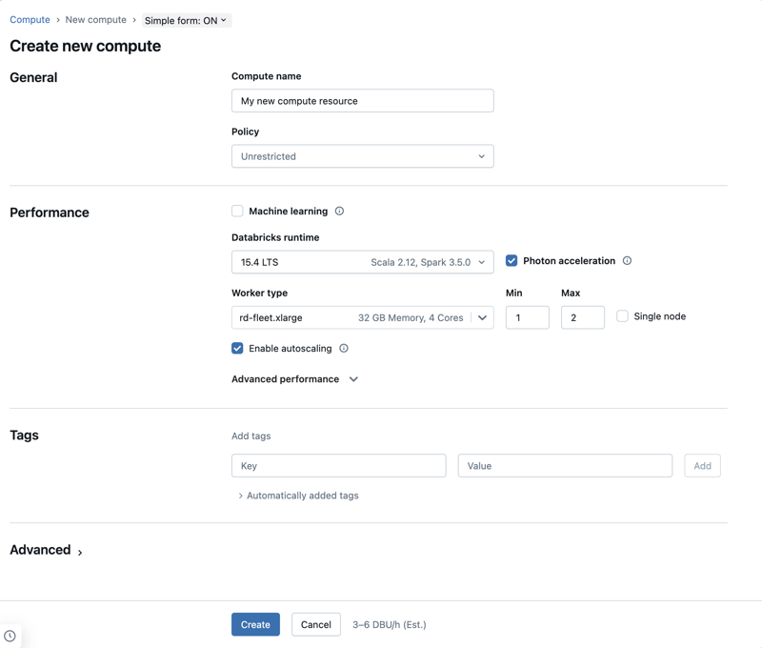
Recent simple compute form. Available policies and fields depend on workspace configuration.
VERIFICATION: The trainer can attach a test notebook and run spark.range(5).count().

Phase C Learner Lab 1 Spark foundations

C1 Create and connect a notebook
- Select New and then Notebook.
- Name it 01 Foundations Orders.
- Confirm Python as the default language.
- Use the compute selector to connect to serverless or the permitted class compute.
- Wait until the notebook shows a connected state.
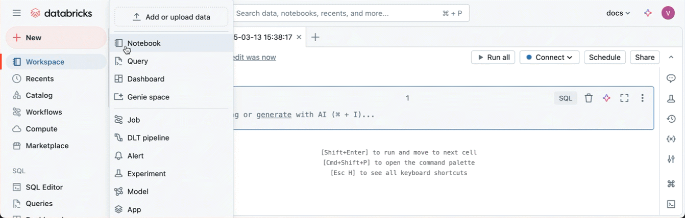
Create a new notebook from the recent workspace New menu.
Notebook toolbar and compute controls in the recent user interface.

C2 Verify the session
PYTHON
print('Learner session ready')
spark.range(5).show()
EXPECTED: Five rows with id values 0 through 4.

C3 Create a DataFrame
PYTHON
from pyspark.sql import functions as F
orders_df = spark.createDataFrame([
(1001, 'Keyboard', 2, 45.00),
(1002, 'Mouse', 1, 25.00),
(1003, 'Monitor', 2, 220.00),
(1004, 'Keyboard', 3, 45.00),
(1005, 'Mouse', 4, 25.00)
], ['order_id', 'product', 'quantity', 'unit_price'])
orders_df.printSchema()
display(orders_df)

C4 Transform and validate
PYTHON
result_df = (orders_df
.filter(F.col('quantity') > 0)
.withColumn('order_total', F.round(F.col('quantity') * F.col('unit_price'), 2))
.select('order_id', 'product', 'quantity', 'unit_price', 'order_total'))
display(result_df.orderBy(F.desc('order_total')))
Check | Expected
Row count | 5
Highest order_total | 440.00
Lowest order_total | 25.00
New column type | Numeric, normally double for this inferred input

EXPLAIN: filter, withColumn, select and orderBy describe transformations. display requests output and triggers execution.

C5 Query with Spark SQL
PYTHON
result_df.createOrReplaceTempView('orders_work')
SQL
%sql
SELECT product,
SUM(quantity) AS units,
ROUND(SUM(order_total), 2) AS revenue
FROM orders_work
GROUP BY product
ORDER BY revenue DESC
Product | Units | Revenue
Monitor | 2 | 440.00
Keyboard | 5 | 225.00
Mouse | 5 | 125.00

C6 Compare storage formats
If the trainer has prepared writable Volumes paths, use your assigned path. Otherwise treat these as instructor demonstrations and continue to Phase D.
PYTHON
base_path = '/Volumes/training_lab/shared/lab_output/student_01'
result_df.write.mode('overwrite').parquet(f'{base_path}/orders_parquet')
result_df.write.mode('overwrite').json(f'{base_path}/orders_json')
result_df.coalesce(1).write.mode('overwrite').option('header', True).csv(f'{base_path}/orders_csv')
CHECKPOINT: Parquet preserves schema efficiently; JSON is self-describing but verbose; CSV needs parsing options. None of these write examples alone creates a governed Delta table.

Phase D Learner Lab 2 Governed Delta table

D1 Confirm your assignment
Replace student_01 everywhere with the schema assigned to you. Do not write into another learner’s schema.
SQL
%sql
SELECT current_user(), current_catalog(), current_schema();
SHOW SCHEMAS IN training_lab LIKE 'student_01';
SHOW GRANTS ON SCHEMA training_lab.student_01;
STOP IF: Your assigned schema is missing or CREATE TABLE is not present. Capture the exact error and ask the trainer; do not request broad admin access.

D2 Save the result as Delta
PYTHON
result_df.write \
.format('delta') \
.mode('overwrite') \
.saveAsTable('training_lab.student_01.orders')
WHAT THIS CREATES: A governed table named orders inside schema student_01 in catalog training_lab. The three parts are catalog.schema.table.

D3 Validate data and metadata
SQL
%sql
SELECT *
FROM training_lab.student_01.orders
ORDER BY order_total DESC;
SQL
%sql
DESCRIBE DETAIL training_lab.student_01.orders;
DESCRIBE HISTORY training_lab.student_01.orders;
- Verify five rows.
- Verify the table format is delta.
- Verify version 0 or the latest rerun version appears in history.
- Open Catalog Explorer and find training_lab > student_01 > orders.

D4 Make a controlled second version
PYTHON
from pyspark.sql import Row
new_order_df = spark.createDataFrame([Row(
order_id=1006, product='Dock', quantity=1, unit_price=120.0, order_total=120.0
)])
new_order_df.write.format('delta').mode('append').saveAsTable(
'training_lab.student_01.orders'
)
SQL
%sql
SELECT COUNT(*) AS row_count FROM training_lab.student_01.orders;
DESCRIBE HISTORY training_lab.student_01.orders;
EXPECTED: Row count is 6 and history contains another WRITE operation.

D5 Optional time travel exercise
Use the history output to identify the earlier version. If your first write is version 0, the following query returns the original five rows.
SQL
%sql
SELECT COUNT(*) AS original_rows
FROM training_lab.student_01.orders VERSION AS OF 0;
DO NOT ASSUME: Version numbers depend on prior reruns. Read DESCRIBE HISTORY and choose a valid version.

D6 Independent challenge
Create a second table named product_summary in your assigned schema. It must contain product, units and revenue, sorted by revenue when queried.
PYTHON
summary_df = (spark.table('training_lab.student_01.orders')
.groupBy('product')
.agg(F.sum('quantity').alias('units'),
F.round(F.sum('order_total'), 2).alias('revenue')))
summary_df.write.format('delta').mode('overwrite').saveAsTable(
'training_lab.student_01.product_summary'
)
EVIDENCE: Show the trainer both tables in Catalog Explorer, the summary query result and DESCRIBE HISTORY for orders.

Phase E Evidence, troubleshooting and cleanup

Learner evidence checklist
Evidence | Pass condition | Complete
Notebook | Runs from top to bottom without a code change | ☐
DataFrame | Five initial rows and correct order_total | ☐
SQL summary | Monitor revenue is 440.00 | ☐
Delta table | Assigned three-level table name exists | ☐
History | At least two versions after append | ☐
Challenge | product_summary exists and is queryable | ☐

Troubleshooting sequence
- Read the entire error; copy the first useful message and the failed object name.
- Confirm the notebook is connected to approved compute.
- Confirm current user, catalog, schema and the exact three-level table name.
- Inspect schema with printSchema and sample rows with display.
- Use SHOW GRANTS for permission errors.
- Ask the trainer with evidence; do not repeatedly rerun destructive cells.

Cleanup
- Learners stop after evidence collection and do not drop shared catalogs or schemas.
- Trainer terminates classic interactive compute or confirms auto termination.
- Trainer decides whether learner tables remain for assessment or are dropped after export.
- Azure admin deletes the dedicated training resource group only when the course is complete and retention requirements are met.
TRAINER SAFETY: Dropping the training catalog removes every learner object. Resolve the exact target and retention decision before any cleanup statement.

Official references
Azure Databricks interfaces change frequently. The steps and screenshots in this package align with the current Microsoft Learn guidance available in September 2026. If a label moves, use the equivalent navigation item in your tenant.
- Create an Azure Databricks workspace — https://learn.microsoft.com/azure/databricks/admin/workspace/create-workspace
- Create and manage notebooks — https://learn.microsoft.com/azure/databricks/notebooks/notebooks-manage
- Configure classic compute — https://learn.microsoft.com/azure/databricks/compute/configure
- Delta Lake tutorial — https://learn.microsoft.com/azure/databricks/delta/tutorial
- Apache Spark documentation — https://spark.apache.org/docs/latest/

